Improve your Candidate attraction
With the increased number of vacancies available and the multiple ways candidates can search for jobs, Recruiters need to change the way they write their adverts. To improve the quality of candidates who apply for your job you need to ensure that your job can be found when searching & once found, the job is attractive enough to apply for. Gone are the days when you advertising a job is doing the candidate a favour – now you are the one needing a favour, you need their CV.
But every job board has different technology & understanding how their search functionality works, and how candidates see your job, is the key to attracting quality candidates.
Candidates on the move
According to Totaljobs, 54% of applications are received from mobile devices with candidates spending an average of 5-8 mins per visit. Candidates using a desktop spend slightly more time at 10-20 mins.
Candidates initially search based on what they want to do (mainly job title, candidates hardly ever use sector to search) and where they want to do it (location).
How your jobs are displayed to the candidate on a mobile device should influence the way you write your advert as you need to grab the candidate’s attention before they apply for your competitors job rather than yours.
Reed
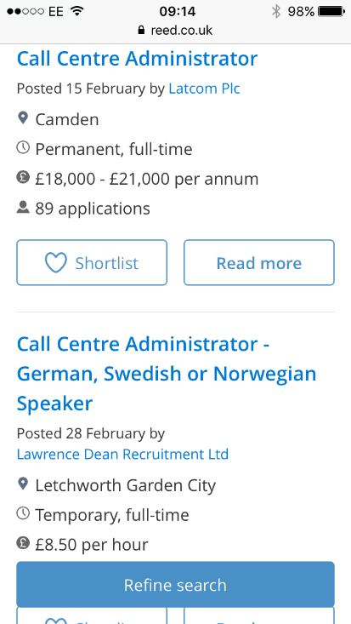

Once the candidate has searched on Reed they are presented with a list of jobs which meet their requirements based firstly on relevancy and then date order. The search results screen only shows the job title, location and salary, it doesn’t show any text from the advert copy & therefore the only piece of
information you have to attract the candidate’s attention is the job title. The job title should include something which makes the job unique or interesting such as sector, benefit or skill that would be attractive to the reader. The ideal job title, according to Reed, is 29 characters.
Totaljobs
Totaljobs is a relevancy based site meaning jobs are displayed to candidates in order of most relevant first. Many things affect the relevancy of the job, the job title making up 70% of the relevancy ‘score’ – the shorter the job title, the higher it scores in the ‘relevancy test’. Unlike Reed who only show the main headings of the job (see above), Totaljobs also show a small amount of text from the advert copy. How this text shows differs:
Where the candidate uses the exact same phrase as contained in your advert the keyword will be shown along with surrounding words – try to make sure your keyword is in a sentence detailing something exciting about the job.
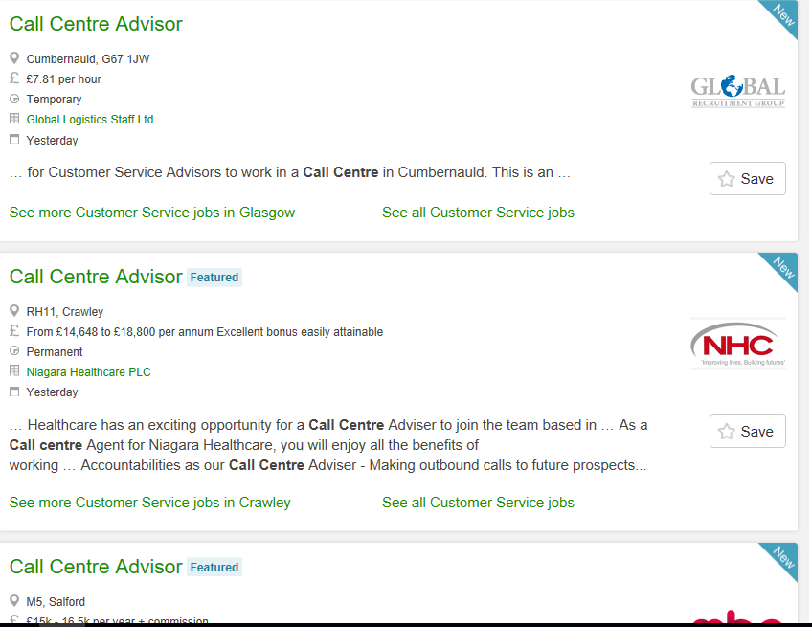

Where the candidate uses a similar phrase as the job title the beginning of your advert will be shown – try to make sure your keyword is in a sentence detailing something exciting and unique about the job being specific, no one believes a job is fantastic or exciting.
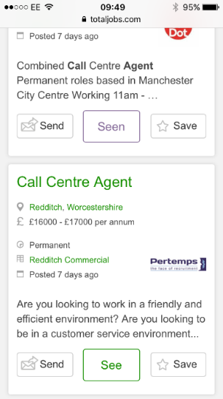

Jobsite
Like Reed, Jobsite only shows the main heading to each job on the search results but unlike Reed, Jobsite is a relevancy based site and therefore recommend keeping job titles short; using the most commonly used job title so people immediately recognise the role & the job is more relevant. But if you can squeeze a small selling point in this would help.
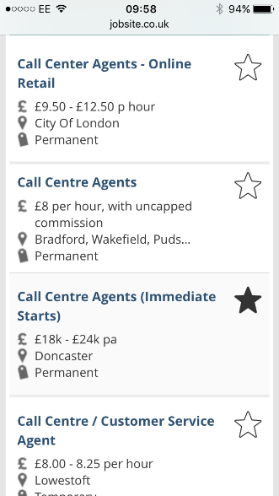

CV-Library
Again, CV-Library is a relevancy based site so keep job titles short and easily recognisable.
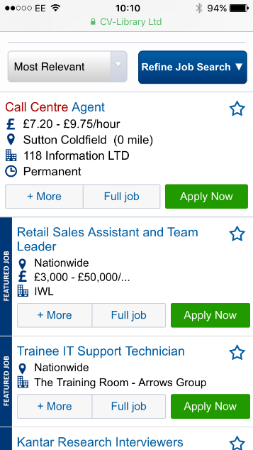

Not sure which job title to use?
If you conduct a job search (as a candidate would) on Totaljobs you’ll be presented with a list of associated job titles listed in popularity.
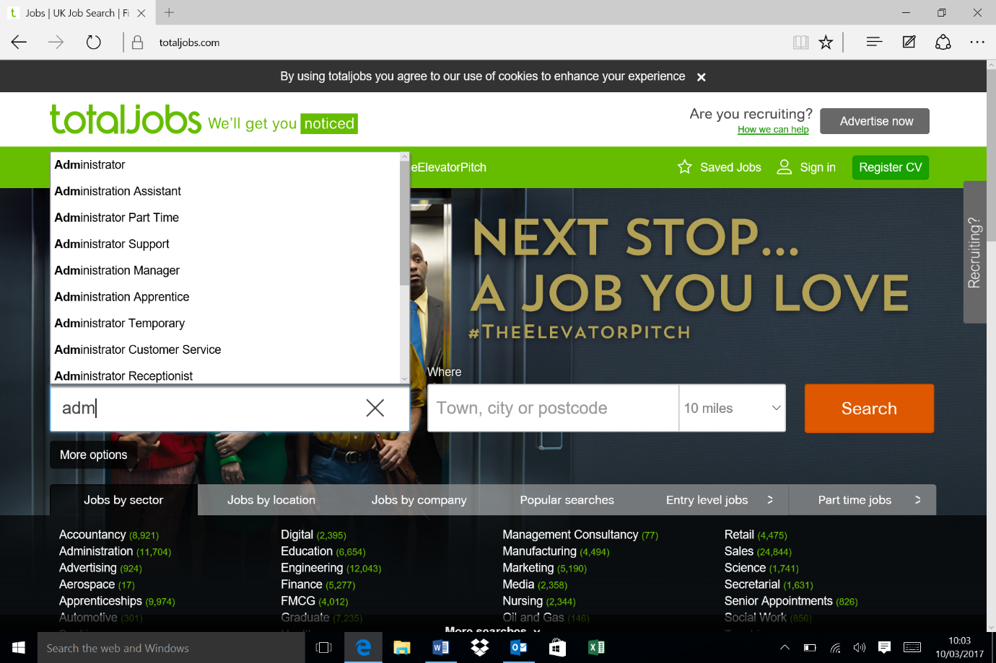

Candidates waiting for you
Most candidates register for job alerts which means they don’t have to search the site as new jobs are sent to them via email.
CV-Library
Nearly a quarter of applications come from job alerts on CV-Library & it is therefore important for your job to be included as they only send one job alert per day with a maximum of 50 relevant jobs per email. To ensure that your job is included the job title needs to be as short as possible, be the job title most people would call the job, be advertised with a postcode and include a salary. Selecting the right sector will also ensure that the job is passed to any affiliate job boards.
Reed
Reed send out Premium jobs on their job alerts if the candidate requests to be notified about new, relevant jobs; Featured and Client Branded adverts are sent to the 250 best matching candidates regardless. They currently send over 7 million job alerts every week, driving over 100,000 applications (about 10% of their total applications per month).
Jobsite
33% of applications are received from job alerts. The sector you chose is the most important qualifier on Jobsite so always select a sector when posting – don’t use ‘other’, candidates are asked to select 4 sectors which will be used to match against your advert. Jobsite only send out a maximum of 40 jobs in each job alert and they base this on relevancy – the short job title being key.

Keywords
The most popular, and searched for keywords on a job board are job titles. For sites that are date orientated, the key word only must be in the advert copy once for it to be matched, for a relevancy based site you need your job to be scored relevant by:
Totaljobs
Repeat the main job title at least 5 times. You can use more but they won’t count towards your relevancy. You can use alternative job titles but Totaljobs will look to match relevant job titles to yours.
CV-Library
Only use the same job title 5 times – any more than this and your job will receive a lower score. They also match words, not just phrases so be careful!
Jobsite
Spread out your keywords evenly throughout the advert & aim for repeating the job title 5/6 times.
Reed
Job title should be in the first paragraph, no limit on the number of times it’s repeated throughout the advert as it’s only the first paragraph that’s weighted heavily for relevancy.

What day is best to post your job?
Totaljobs traffic wc 6th Feb 2017, visits & applications:

& CV-Library can show us what time of the day people apply for jobs:

Reed tell us that mobile users are searching between 9am – 10 am & 8pm – 9pm, desktop 11am.
CV-Library believe that there is less competition to get your job seen if it is sent out on a job on a Monday.
So, the best day to advertise your job? Sunday afternoon!

How long before the reader gets bored?
Reed report that 300 words produces the most effective adverts.
CV-Library believe the first 50 words are the most important with an overall length not exceeding one side of A4.
Totaljobs think 2/3 of a side of A4 is about right.
All job boards agree that a mixture of paragraphs and bullet points make the advert more appealing, but keep bullet points to a list of 5 or 6, no more.

What else…….
A salary on Reed will result in 20% more applications whereas 68% of candidates are more likely to respond to an advert with the salary showing on Jobsite.
On all 4 job boards using a postcode improves the relevancy score of an advert, using a county greatly lowers a jobs visibility, both when searching and appearing on a job alert.
On Jobsite, you can advertise one job with 19 locations but to maximise the mapping make sure each location is 20 miles apart.
Totaljobs have introduced Travel Time, a new feature where the fastest route between a jobseeker and a job is displayed. To benefit from this new feature, you must post the job with a full postcode. The postcode not only benefits the candidate with Travel Time but consultants too, on average a job posted with a postcode attracts 12 more applications per job advert.
On average Totaljobs receive 19 applications per job, CV-Library 18.1. Obviously, this varies across sector and location but if you are advertising a popular job in a large town and only getting a handful of applications then your advert isn’t working.
Always finish your advert with a call to action!

