HEALTH AND SAFETY DECLARATION
in relation to Coronavirus Disease (COVID-19)

As outlined in our Health and Safety Policy, the Company will take reasonably practical steps to provide a safe and healthy workplace. This includes minimising the spread of infectious diseases in the workplace.
Following the recent outbreak of the Coronavirus, in order that we can keep everyone safe, we ask that you complete, sign and return to us this declaration.

Full name: Click to enter your name
Address: Click to enter your address

I declare :

That neither myself nor my immediate family (or members of my household if flatting) have been to or visited any of the following countries or areas of concern in the last 14 days:

Please Note: The Ministry of Health website is constantly being updated.

If you or your immediate family or household have travelled overseas in the past 14 days please list below:

- Click to enter details

I also declare that either during or after travelling that I and/or my immediate family or household have not exhibited any of the following signs or symptoms in the last 14 days:
- Fever
- Cough
- Shortness of breath or difficulty breathing

In addition, I undertake to immediately advise my Manager at Beyond Recruitment if in the future either myself or my immediate family or household:

- Travel to or from a country or area of concern listed above or to or from any additional countries or areas of concern as updated and advised by the Ministry of Health https://www.health.govt.nz/our-work/diseases-and-conditions/covid-19-novel-coronavirus/covid-19-novel-coronavirus-health-advice-general-public/covid-19-novel-coronavirus-countries-and-areas-concern
- Exhibit the signs and symptoms of COVID-19
- Are diagnosed as having COVID-19

Date: Click to enter the date.

Signature: ____________________________________________

Notes:

Category 1a countries and territories
All New Zealand citizens and permanent residents (and close family members) inbound from Category 1a countries and territories are requested to register with Healthline (0800 358 5453) and to undertake 14 days self-isolation starting from the date of the departure from that country or territory.

Category 1b countries and territories
Category 1b countries and territories do not have travel restrictions in place. People who have been in Category 1b countries and territories (excluding airport transit) are requested to register with Healthline (0800 358 5453) and self-isolate for 14 days starting from the date of departure from a Category 1b country and territory.

Category 2 countries and territories
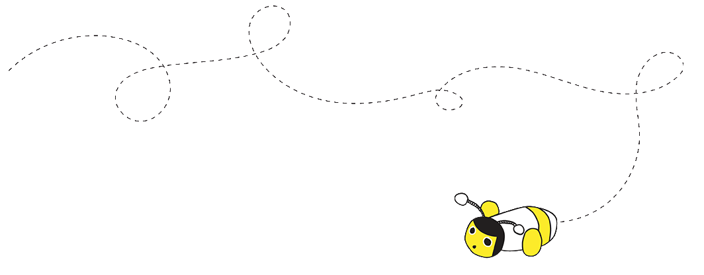
People who have recently travelled from Category 2 countries and territories (excluding airport transit) should be aware of the COVID-19 symptoms. You do not have to self-isolate if you are well. Anyone who develops symptoms within 14 days of departing the Category 2 country and territory should contact Healthline (0800 358 5453).

