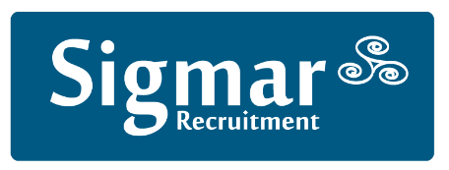
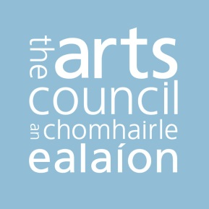

Candidate Information Booklet

Assistant Principal

HR Director
Full-time Permanent Role

Closing date – 12 noon, Monday 3rd of October

Please note, applications submitted after the closing date will not be considered.

The Arts Council is committed to a policy of equal opportunity and encourage applications from all sections of the community under all ten grounds as set out in our Equality, Human Rights and Diversity Policy

For more information, visit: http://www.artscouncil.ie/equality-human-rights-diversity/

Contents
- Introduction
2. Overview
3. Required Competencies for the Role
4. Basis of Employment
5. Office Location
6. How to Apply
7. Selection Methods
8. Medical and Security
9. Eligibility
10. References & Verification
11. Enquiries/Further Information
12. Confidentiality
13. Other Important Information
14. Applicant Privacy Statement

- Introduction

This competition is being managed by Sigmar Recruitment. All queries are to be directed to Jennifer Ward at 01-4744660 or jward@sigmar.ie.

- Overview

This booklet provides an overview of the competencies, salary scales, and application and selection process for candidates wishing to submit an application for Assistant Principal Officer role within the Arts Council.

- Required Competencies for the Role

The successful candidate must be able to demonstrate that they possess the requisite competencies required for this senior management position. The required competencies for the role of Assistant Principal (AP) are outlined below.

Source: Public Appointments Service

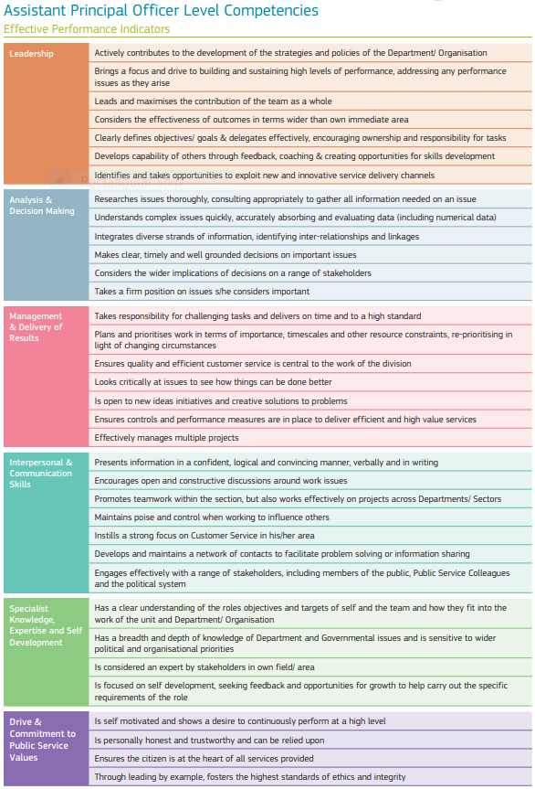

Source: Public Appointments Service

Reporting Structure and Leadership:

The role of Assistant Principal is a senior management role within the Arts Council. Candidates must be able to demonstrate that they have the requisite skills, knowledge and experience in order to provide effective team leadership, ensuring a focus on continuous improvement and service delivery to meet the business requirements of the organisation.

- Basis of Employment

Salary

The salary scale for Assistant Principal, including the required pension contribution, is set out below.

P1 €70,399; P2 €72,991; P3 €75,620; P4 €78,258; P5 €80,891; P6€82,409; LSI1 €85,067*; LSI2 €87,734**
*After three years’ service at Point 6. **After three years’ service at Long Service Increment 1. (Pay scale as at 1st February 2022)

Candidates should note that entry will be at Point 1 of the scale and the rate of remuneration may be adjusted from time to time in line with Government pay policy.

Different pay and conditions may apply, if, immediately prior to appointment the appointee is an existing public or civil servant. Public service pension terms and retirement age conditions will apply in accordance with pension arrangements in the Arts Council depending on the prior status of the successful appointee.

Subject to satisfactory performance, increments may be payable in line with current Government Policy.

Annual Leave

The annual leave entitlement for this role (based on a full-time role) is 30 days per year.

Probation Period
In accordance with the Arts Council Probation Policy a 6 month probationary period applies.

- Office Location
You will be based at the Council offices at 70 Merrion Square, Dublin 2, but you may occasionally be required to work at other locations. The Council reserves the right, at its discretion, to change this location to any other place within Ireland. You will be required to travel from time to time in performance of your duties.

Please note: We are following Government Guidelines in relation to COVID_19. We currently operate a blend of working from home and attendance at the office.

- How to Apply

To apply, please email a letter (no more than two pages) to Jennifer Ward jward@sigmar.ie, with the role title in the subject line, outlining why you are interested in the opportunity and where you believe your skills, knowledge and experience meet the requirements of the role. Additionally, please attach a comprehensive curriculum vitae (C.V.) clearly showing the relevant achievements and experience in your career to date. (Please save your document in one of the following formats .doc, .docx, .rtf or .pdf).

Sigmar Recruitment will acknowledge receipt of all applications. If you do not receive an acknowledgement within two working days of applying please email mike@sigmar.ie.

- Selection Methods

The selection process may include:

- shortlisting of candidates on the basis of the information contained in their application (letter and CV) to reduce the list of candidates to a more manageable number for interview;
- an interview which may include a presentation by the candidate;
- completion of a psychometric personality questionnaire;
- a second interview which may also include a presentation or other exercise.

In the event of a short-listing exercise being employed, an expert selection panel will examine the applications and assess them against pre-determined criteria based on the requirements of the position. It is therefore in your interest to provide a detailed and accurate account of your qualifications and experience in your application.

- Medical and Security

Candidates who come under consideration for appointment will be required to undergo a pre-employment medical examination in addition to Garda Vetting, which will also have regard to Child Welfare and Protection issues.

- Eligibility
Citizenship Requirements
Eligible Candidates must:
a) A citizen of the European Economic Area. The EEA consists of the Member States of the European Union, Iceland, Liechtenstein and Norway; or
b) A citizen of Switzerland pursuant to the agreement between the EU and Switzerland on the free movement of persons; or
c) A non-EEA citizen who is a spouse or child of an EEA or Swiss citizen and has a stamp 4 visa; or
d) A person awarded international protection under the International Protection Act 2015 or any family member entitled to remain in the State as a result of family reunification and has a stamp 4 visa or
e) A non-EEA citizen who is a parent of a dependent child who is a citizen of, and resident in, an EEA member state or Switzerland and has a stamp 4 visa
To qualify candidates must meet one of the citizenship criteria above by the date of any job offer.
Candidates that are not citizens of the aforementioned countries must have the necessary permissions to work in Ireland. It shall be the responsibility of the candidate to ensure these permissions are in place.

It is the individual’s responsibility of former public or civil servant candidates to ensure their eligibility to apply. In particular, potential candidates who participated in a voluntary severance/redundancy or early retirement programs, received a redundancy payment or are in receipt of a public sector pension, should familiarise themselves with their individual conditions pertaining to public sector re-employment and declare same if applying.

- References and Verification

It would be helpful if you would start considering names of individuals whom you feel would be suitable referees that we might consult (two to three names and contact details). The referees do not have to include your current employer, but he/she should be in a position to provide a reference for you. Please be assured that we will only collect the details and contact referees should you come under consideration for appointment.

Candidates will be required to provide verification of citizenship eligibility and educational qualifications in a form acceptable to the Arts Council.

- Enquiries/Further Information

If you require additional information or to arrange a confidential discussion in relation to the opportunity, please email jward@sigmar.ie.

- Confidentiality

Subject to the provisions of the Freedom of Information Act 2014 applications will be treated in strict confidence.

You can expect that all enquiries, applications and all aspects of the proceedings are treated as strictly confidential and are not disclosed to anyone, outside those directly involved in the recruitment process.

- Other Important Information

The Arts Council will not be responsible for refunding any expenses incurred by candidates including preparation for/attendance at interview or relocation.

Candidates should note that canvassing will disqualify and will result in their exclusion from the process.

The above represents the principal conditions of employment and is not intended to be the comprehensive list of all terms and conditions of employment which will be set out in a detailed employment contract to be agreed with the successful candidate.

- Applicant Privacy Statement
Data Controller – The Arts Council & Sigmar Recruitment Consultants Ltd.

Purpose of Processing
The Arts Council and Sigmar Recruitment conducts recruitment processes to fill vacancies within the organisation. When applying for these competitions, applicants are asked to submit documents, e.g. application form, CV and/or cover letter.

This applicant privacy statement has been produced for applicants applying for positions in the Arts Council. Further information on the General Data Protection Regulation (G.D.P.R.) and subject access requests can be found on the Arts Council website http://www.artscouncil.ie/privacy-policy/.

There is a legal basis for processing this data and the data is shall be shared as necessary, as outlined below.

Recipient/Shared With | Reason
Arts Council Human Resources Unit and Sigmar Recruitment | Storing applications, acknowledging applications and corresponding with applicants. Certain information is also required for inclusion in the contract for the successful applicant.
Selection Board | Information required for shortlisting and interview process.
Current/previous employers | For existing Civil Servants: Performance management and sick leave checks  Non-Civil Servants: Reference checks.

The Arts Council and Sigmar Recruitment are compliant with all aspects of G.D.P.R. and all related data is managed in compliance with the relevant regulations.

Successful Candidates Information
The information supplied by successful candidates will be held on their personnel file for the duration of their employment with the Arts Council, and for such other period of time as may be required following their departure from the Arts Council.

Unsuccessful Candidates Information
The Arts Council and Sigmar Recruitment will hold the information of unsuccessful candidates for a period of 12 months following the appointment of the successful candidate.

Applicants Entitlements
The Arts Council and Sigmar Recruitment recognises that applicants have the following entitlements in relation to the data that they have supplied as outlined below:

- Access - Applicants can request and receive access to their data at any time and can request and receive a copy of this data.
- Erasure - Applicants can request to have their data erased.
- Rectification - Applicants can have any incorrect information corrected.
- Objection - Applicants can object to this information being processed.
- Complaints - Applicants can make a complaint to our internal Data Protection Officer (as outlined below):
E-mail: dataprotection@artscouncil.ie & privacy@sigmart.ie
or
Write to: Data Protection Officer, Data Protection Officer,
The Arts Council, Sigmar Recruitment Consultants Ltd.
70 Merrion Square, 13 Hume Street
Dublin 2. Dublin 2.

Further Information on Data Protection
For further information on the Data Protection please see www.dataproctection.ie or telephone +353 57 8684800 or 1890 252 231.

